Step 1 : reboot the server

Step 2: on grub prompt select edit for the kernel

Step 3:

locate line with /vmlinuz entry

on this line replace rhgb quite with init=/bin/bash

Step 4:

press CTRL+x

to boot

Step 5:

when on # prompt

mount -o remount,rw /

Step 6:

passwd root

change the password

Step 7:

touch /.autorelabel

Step 8:

reboot -f

2nd Method

Step 1 : reboot the server

Step 2: press e at the kernel boot time

Step 3:

Find line start with linux16 (in RHEL 7) and write rd.break at the end of line.

Step 4:

press CTRL+x

to boot

Step 5:

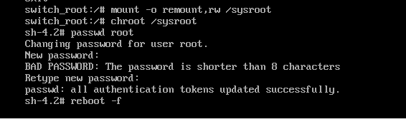

Login again with your new root password

-------------------------------------------------------------------------